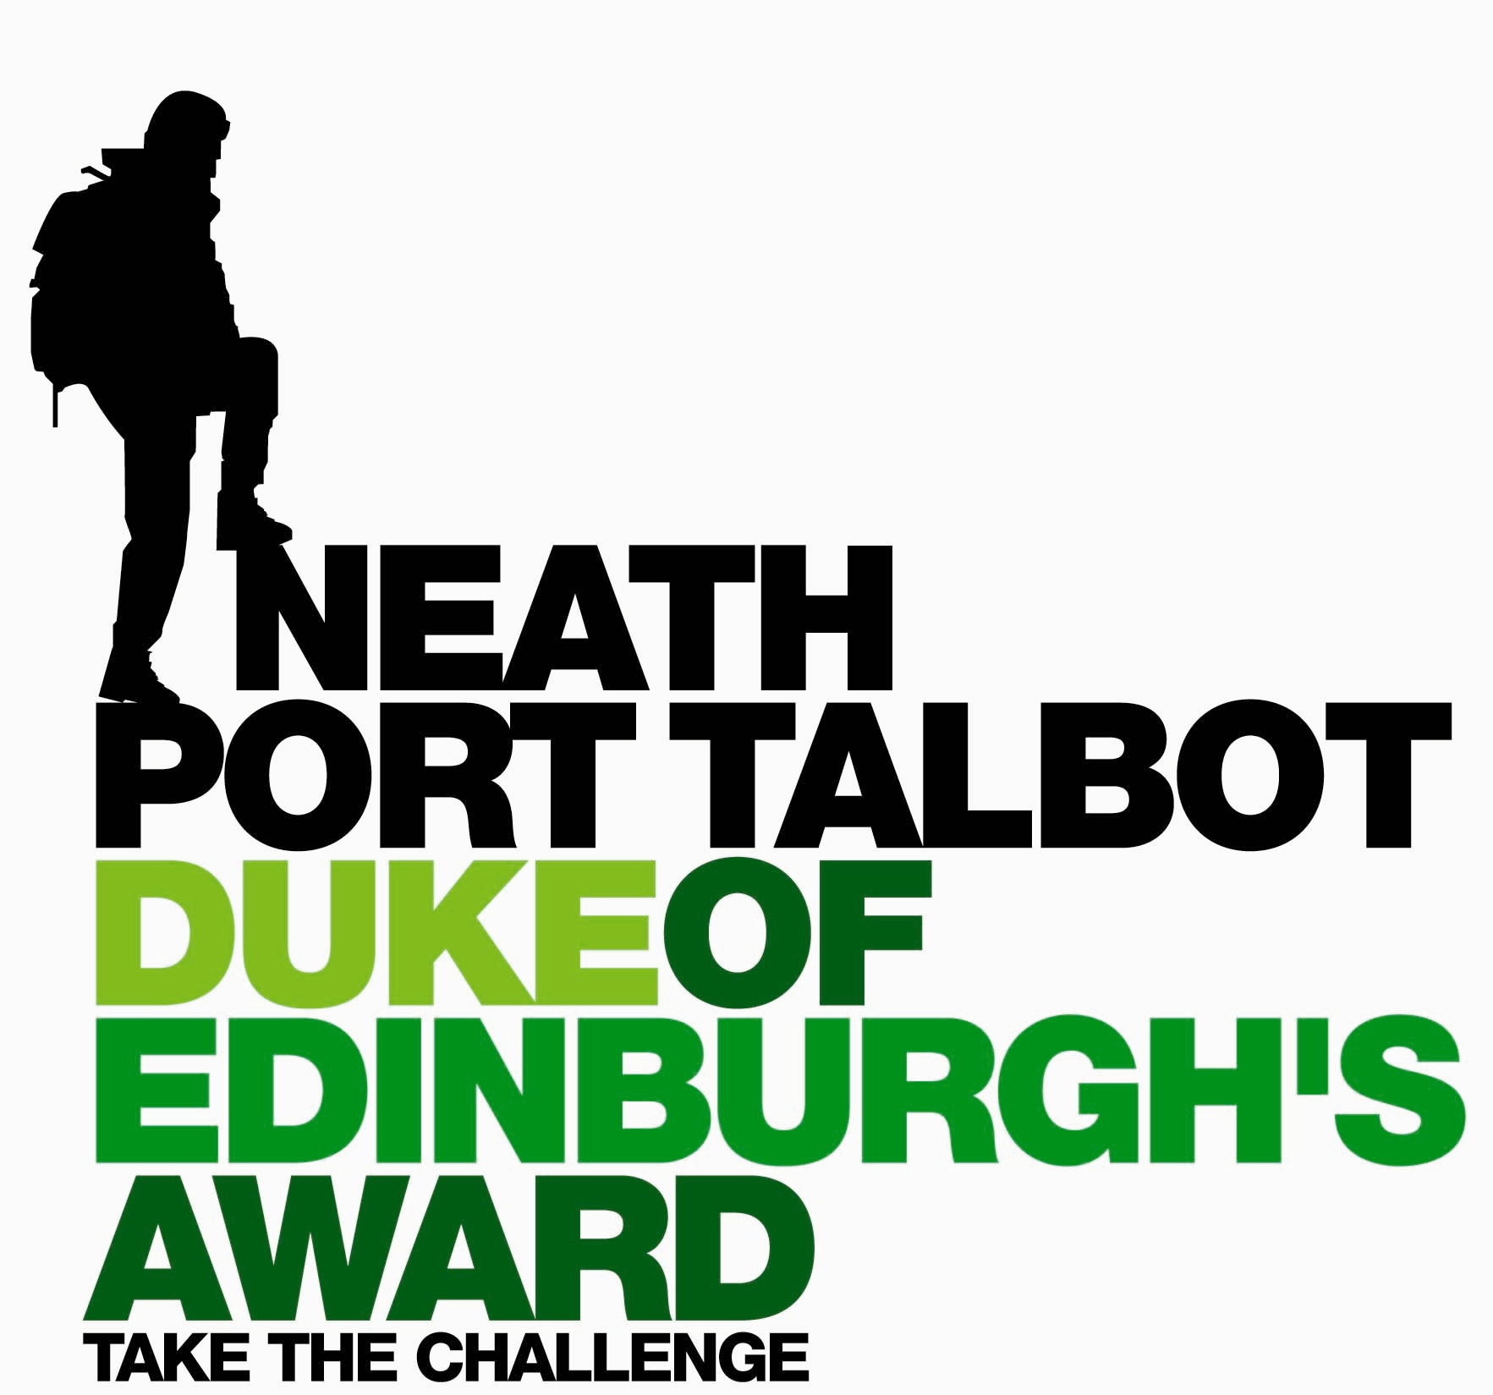
Gold Kit List

Clothing etc

- Walking Boots 1x pair
- Walking Socks, enough for length of exped.
- Underwear, enough for length of exped.
- Thermal top(s) / tee shirt(s) ensure you have one top with long sleeves in case of sunny weather.
- A ‘mid layer’ top such as a fleece, avoid ‘hoodies’ etc as they are really heavy and take ages to dry.
- A spare mid layer top, again fleece is best
- Trousers (NOT jeans) optional = thermal leggings to wear at night or during the day if it’s cold.
- Waterproof jacket and trousers
- Hat and gloves, again fleece is good as it dries fast
- Optional = trainers or flip flops for evenings
- Gaitors, these are optional but recommended, they will go a long way to keeping your feet fry.
- Sunhat – if there is sun forecast you MUST have a sun hat, a wide brimmed hat is best by far, you can buy them cheaply and they are light, you can also use a baseball cap but they aren’t as good.
PERSONAL KIT (TO CARRY) continued…..

- Head Torch & spare battery
- Water bottle to hold 2 litres
- Plate, bowl, Mug, Knife, fork, spoon
- Matches in waterproof container or bag
- Pocket Knife (optional)
- 1x Wash kit (tooth brush & paste soap hand towel)
- Money for campsites
- Suncream, essential for summer expeds, you can buy ‘all day long’ suncream which means you can carry less and only apply once.
- Orange survival bag – ESSENTIAL!

Darren Clapham Tel : 07980727116
Duke of Edinburgh's Award Email : d.clapham@npt.gov.uk
Development Officer Post : Llangatwg Comprehensive School, Cadoxton, Neath, SA10 8DB

Group Kit

- Tents, you will use either 1 or 2 man tents and then split them between you, for example someone has the tent inner and poles and someone has the outer and pegs. We provide tents but u can use toy own if you like.
- 2-3x Stoves & fuel, we can provide the stoves and fuel bottles but if you are using trangias then you need to buy Meths.

The next items you will carry between you but you MUST communicate now and decide who will buy what, you have to have all of the stuff below…

- Washing up liquid and scourer, or brillo pad style scourers.
- Tea towel
- Camera (optional)
- Pack of cards (optional)
- Notebook & pen/pencil to record the information for your aim (final exped only)
- Trowel and toilet paper
- Water purifying tablets, either go to an outdoor shop and get whatever brand they have or put ‘lifesystems chlorine diox’ into google. You only need one pack per group but you have to have them

PERSONAL KIT (TO CARRY)

- Large Rucksack, over 65 litres (I can lend you one if you book one in advance)
- Sleeping mat – must be proper camping sleeping mat, not an exercise or yoga mat, they won’t keep u warm.
- Sleeping bag appropriate to the time of year. If you feel the cold in the night then for practice expeds you can bring a second sleeping bag to leave on the minibus and collect at camp so you have 2 in the night. You HAVE to carry one sleeping bag though. I also have lots of spare sleeping bags which you can borrow if you let me know.
- Drybag, if you haven’t got one yet then see Darren, they cost £10
- Food - see food document on ‘Open Gold Centre’ page of www.nptdofe.co.uk
- Emergency food rations – see food document on website
- Whistle
- Map and compass
- First aid kit, just a small basic one, you can by them ready made up from supermarkets or boots

